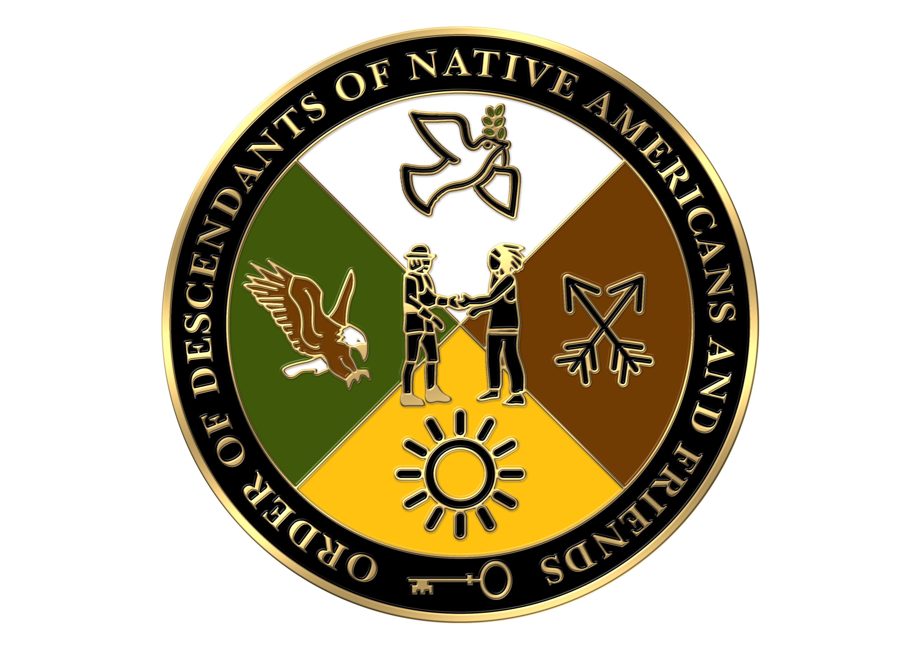

ORDER OF DESCENDANTS OF NATIVE AMERICANS AND FRIENDS

Preparation of Lineage Papers
Instructions for Applicants

Please read the following information carefully before preparing your lineage papers.

Contact the Registrar General with any questions you may have.

1. The application must be typed and completed in the space provided. Please do not staple documents to the application. Only one set of documentation is required.

2. Names should be written in full, including maiden name of wives if known. Please state the male first in each generation.

3. Include dates of birth, marriage and death in the following format: 4 Oct 1623.

4. If information is unknown or not applicable, please the leave the blank empty.

5. The proof of each generation must be listed on the lineage paper by document, and volume (title and applicable page numbers). Documents providing proof of each generation/event are required. Pertinent information should be underlined in red on each proof for easy verification. In red also put the Generation in the upper corner of each proof; i.e., Generation 1.

6. Verifiable sources may include: birth, death and marriage certificates; federal and state census records; tombstone transcriptions and photographs (with the name and location of cemetery stated on reverse of photograph); bible records (with copyright page included), published town histories and vital records; published family genealogies; and similar documentation. Family histories and genealogies which do not cite original source material are not acceptable. A copy of the title page from all sources must be provided. Find-A-Grave is not acceptable unless information is legible on the tombstone. Family group sheets from genealogy web sites are not acceptable.

7. Approved lineage papers from other hereditary societies or orders MAY be acceptable for submission upon consideration and approval by the Registrar General of the Order. No approved lineage papers from hereditary societies which do not require the submission of a full set of proofs as a prerequisite for membership will be accepted by ODNAF.

8. In cases when another society’s approved lineage papers are submitted as evidence of the lineage, it is necessary to list all relevant proofs on the primary ODNAF application. In these cases, it is not necessary to include copies of the actual proofs. A record copy of the referenced application, bearing the signature of the approving Genealogist/Registrar, the date of the approval, and the applicant’s membership number(s), must be supplied. In addition, any such application must reflect the applicant’s lineage to the qualifying ancestor.

9. The computer application is a fillable pdf file. Please use “tab” to move between spaces. If the text for a given field is too long, please abbreviate so that the information stays within the space provided. Do not “wrap” text onto a new line.

10. Please print this application onto only 2 sheets of letter-size paper (double-sided). Page 5 is optional but may be included when necessary.

SUBMISSION OF ODNAF LINEAGE PAPERS

Instructions for Applicants

1. The completed application and one photocopy of the application, both with original signatures should be mailed with all proofs and applicable fees to the Registrar General.

2. Applicable Fees:
Life membership and application fees shall be:

  - Two hundred seventy five dollars ($275) for General Life members (members assigned membership numbers beginning with #76). The applicable fee ($275) shall be submitted with the application, along with a thirty-five dollar ($35) non-refundable application fee for a total of $310, payable to ODNAF.

b. Supplemental Fee: Non-refundable $35.00, payable to ODNAF.

3. If the original pedigree is disapproved by the Registrar General, the application fee ($35) will be retained by the Society for services rendered.

4. Please submit completed application, photocopies, documentation and applicable fees to:

Cary Stone-Greenstein
1280 Rudolph Road, Apt. 5K
Northbrook, IL 60062-1449
847-724-7424
cary-stone@msn.com

